Emotive Synonyms

🔹 What is Emotive Synonyms
# Source: AI Source: Provided by: [Data Path: Persons Table -> ID Column: 1, Name_En Column: Motasem Essam] -> From: [Chatgpt (GPT-4-turbo)] on [7/30/2025]
Emotive synonyms are words that have similar core meanings but differ in the emotional tone or intensity they convey. They reflect the speaker’s attitude, feelings, or emotional coloring, even when the factual meaning is nearly the same.

🧠 Definition:
# Source: AI Source: Provided by: [Data Path: Persons Table -> ID Column: 1, Name_En Column: Motasem Essam] -> From: [Chatgpt (GPT-4-turbo)] on [7/30/2025]
Emotive synonyms are words with similar denotative meanings but different connotative or emotional impacts, often expressing approval, disapproval, intensity, or mood.

📌 Key Features:
# Source: AI Source: Provided by: [Data Path: Persons Table -> ID Column: 1, Name_En Column: Motasem Essam] -> From: [Chatgpt (GPT-4-turbo)] on [7/30/2025]
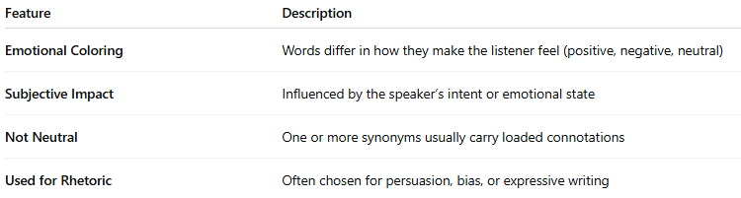
Feature | Description
Emotional Coloring | Words differ in how they make the listener feel (positive, negative, neutral)
Subjective Impact | Influenced by the speaker’s intent or emotional state
Not Neutral | One or more synonyms usually carry loaded connotations
Used for Rhetoric | Often chosen for persuasion, bias, or expressive writing

📚 Examples of Emotive Synonyms:
# Source: AI Source: Provided by: [Data Path: Persons Table -> ID Column: 1, Name_En Column: Motasem Essam] -> From: [Chatgpt (GPT-4-turbo)] on [7/30/2025]
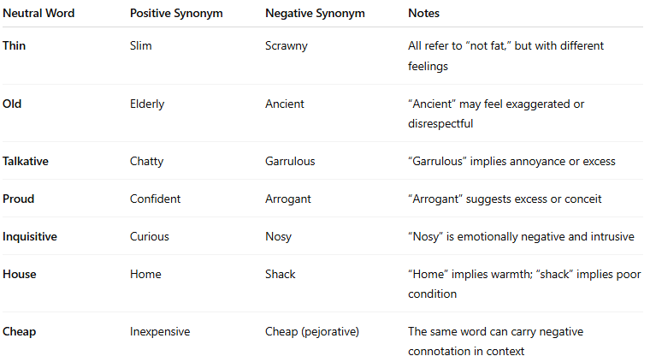
Neutral Word | Positive Synonym | Negative Synonym | Notes
Thin | Slim | Scrawny | All refer to “not fat,” but with different feelings
Old | Elderly | Ancient | “Ancient” may feel exaggerated or disrespectful
Talkative | Chatty | Garrulous | “Garrulous” implies annoyance or excess
Proud | Confident | Arrogant | “Arrogant” suggests excess or conceit
Inquisitive | Curious | Nosy | “Nosy” is emotionally negative and intrusive
House | Home | Shack | “Home” implies warmth; “shack” implies poor condition
Cheap | Inexpensive | Cheap (pejorative) | The same word can carry negative connotation in context

🔁 Comparison with Other Synonym Types:
# Source: AI Source: Provided by: [Data Path: Persons Table -> ID Column: 1, Name_En Column: Motasem Essam] -> From: [Chatgpt (GPT-4-turbo)] on [7/30/2025]
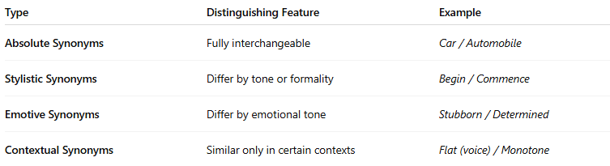
Type | Distinguishing Feature | Example
Absolute Synonyms | Fully interchangeable | Car / Automobile
Stylistic Synonyms | Differ by tone or formality | Begin / Commence
Emotive Synonyms | Differ by emotional tone | Stubborn / Determined
Contextual Synonyms | Similar only in certain contexts | Flat (voice) / Monotone

🧾 Use in Writing:
# Source: AI Source: Provided by: [Data Path: Persons Table -> ID Column: 1, Name_En Column: Motasem Essam] -> From: [Chatgpt (GPT-4-turbo)] on [7/30/2025]
Writers and speakers choose emotive synonyms to:
- Influence readers’/listeners’ emotions
- Reflect bias or character opinions
- Create mood or tone
Example:
“The rebel was executed.” vs. “The freedom fighter was martyred.”
— Same action, different emotional framing.

